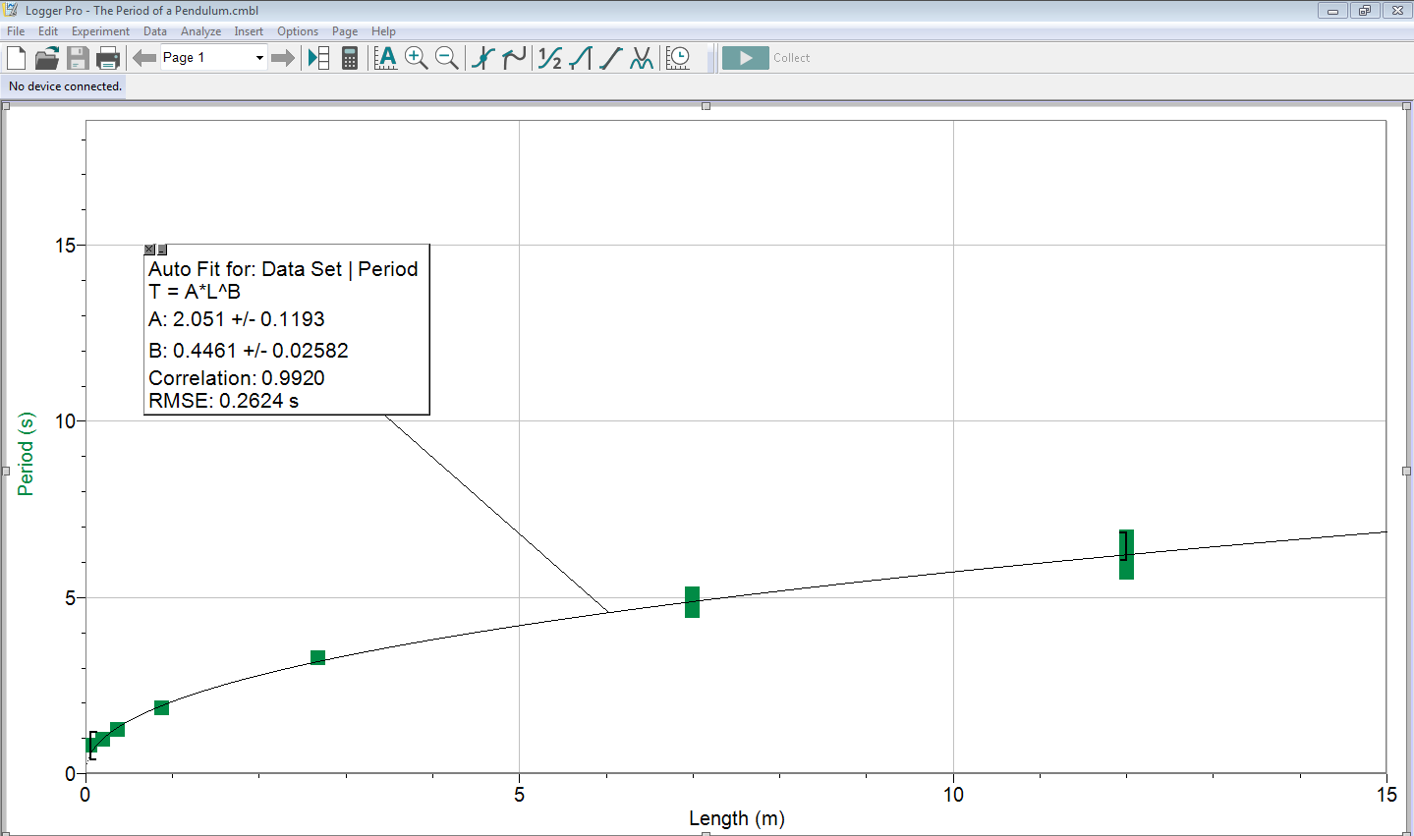

Figure 1. Period of pendulum swing as a function of length. The relationship is described by the equation Period=(2.05±0.12)s\*Length^(0.45±0.03)m. Error bars of period and length are 0.1m and .001m respectively, and are small enough to not show up on the data points. The uncertainty is our period measurements comes from the combination of uncertainty of length and time. However, this uncertainty is smaller than the data points, so it is not shown on the graph.